The following is a step-by-step guide to accessing Facebook Live Worship Services without a facebook account, all live videos are also saved to this same page and available to watch anytime, simply follow the same procedures outlined below:

- Open Web Browser
(Safari, Chrome, Explorer, Firefox, etc.)

- Go to this page (or simply click on this link): facebook.com/SSLVwa

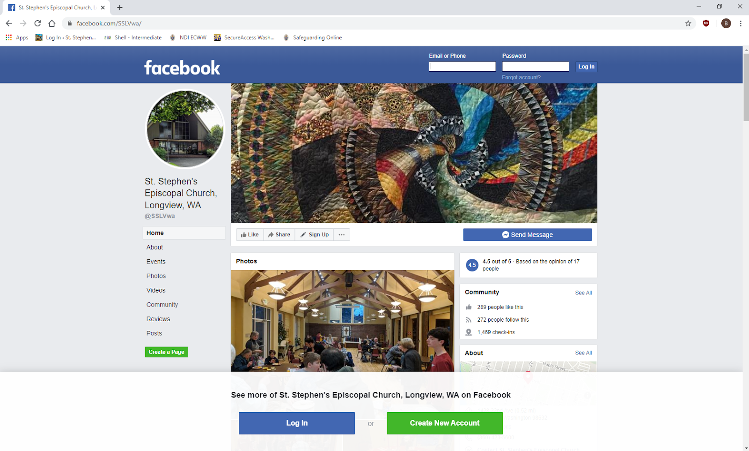
- Once there, ignore the log in/sign up boxes (it will stay on your screen, you cannot close it)

IGNORE ME

  - You may have to close a sign in prompt that pops up in the middle of your screen, do so by clicking on the “not now” in the lower right
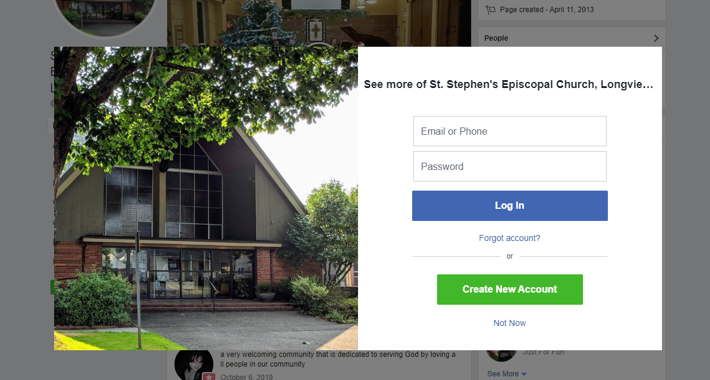
Click
“Not Now”

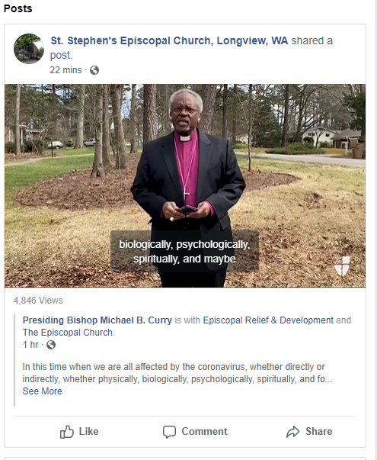
- Scroll down the page past the information sharing sections (photos, videos, etc) to the “posts” section

- The live video will appear in the posts section

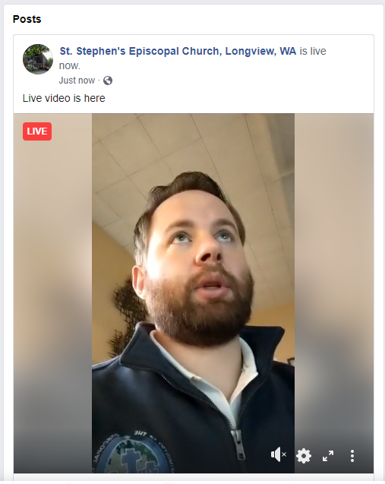

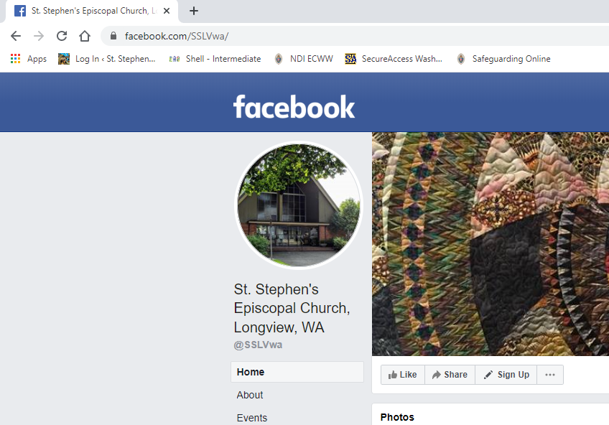
NOTE: You May Have to “Refresh” the page if you go to the page before the live video has started
CLICK “Refresh” If you don’t see the live video

- If volume is off, click on the “horn” in the video post to turn volume on

- Click on the video in the post (where the image is) to watch the live stream in a larger window

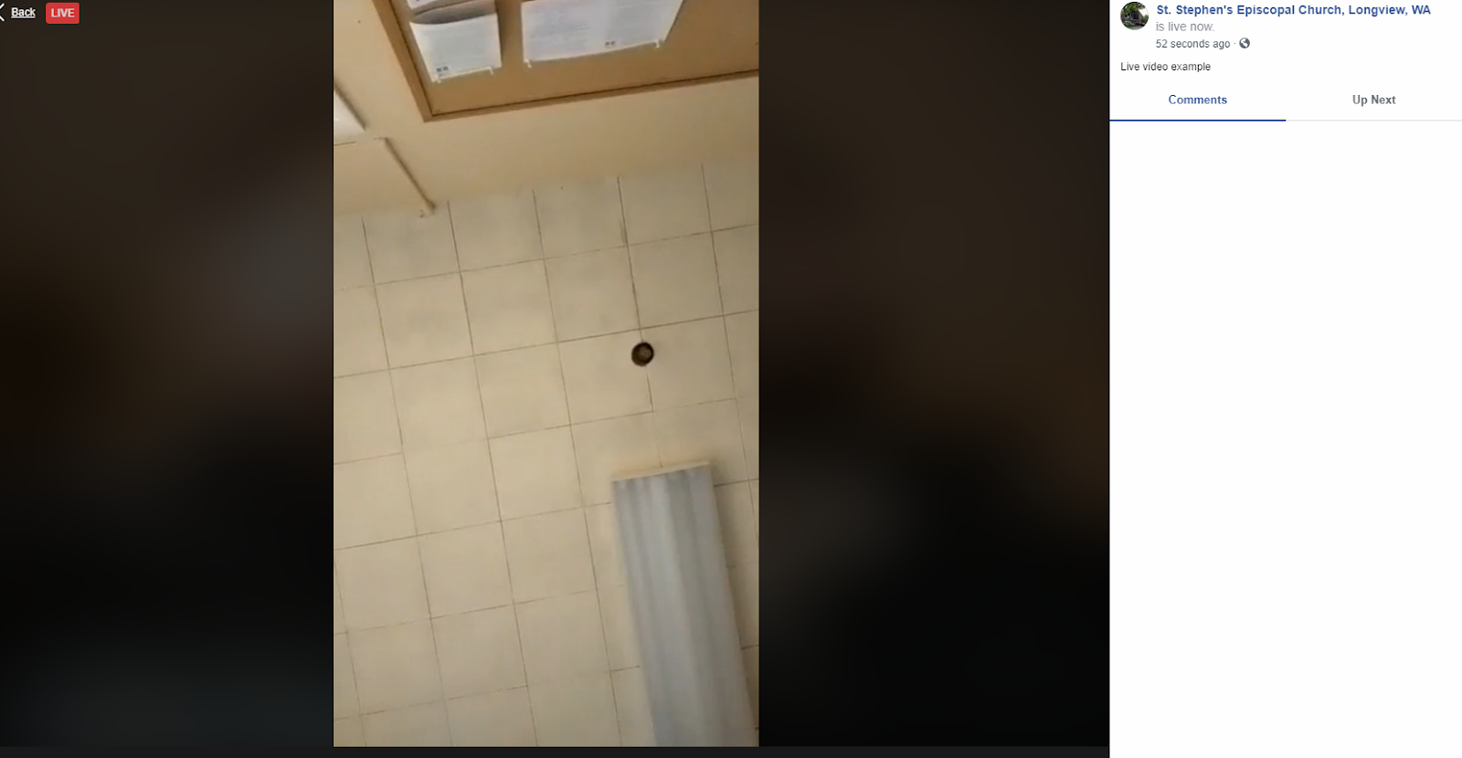
Click In the Middle of the Picture in order to bring up a larger window (seen below)

